1. docker pull hello-world

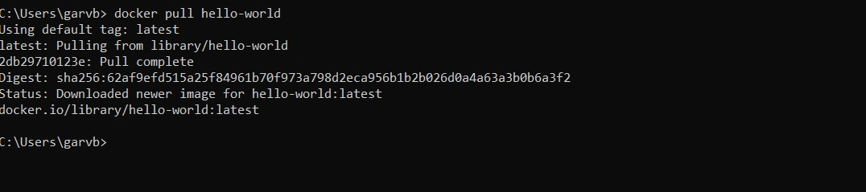

1. docker run hello-world

1. docker images

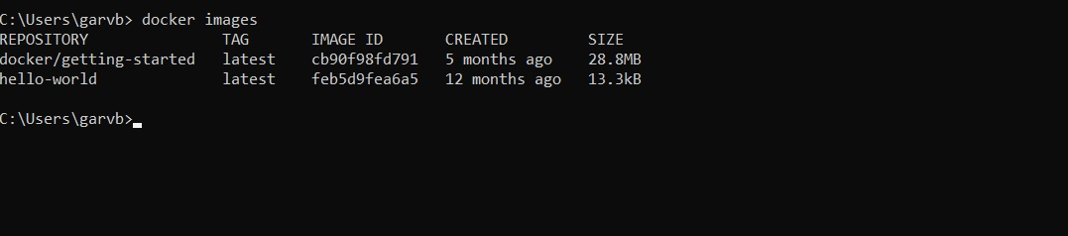

1. docker checkpoint command

1. docker config command

1. docker ps

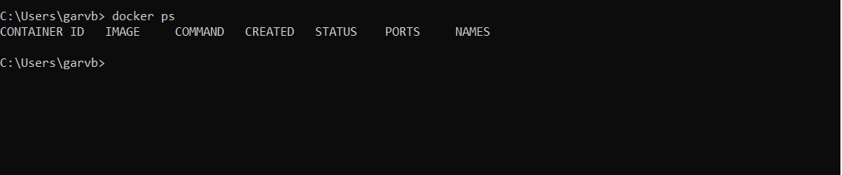

1. docker ps -a

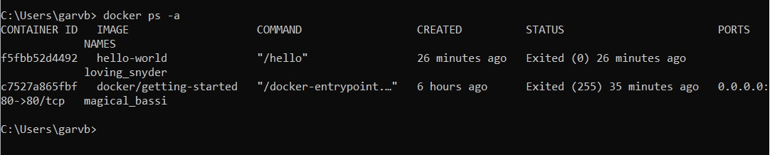

1. docker stop <name>

1. docker rm <name>

1. docker rmi <name>

1. docker run –help

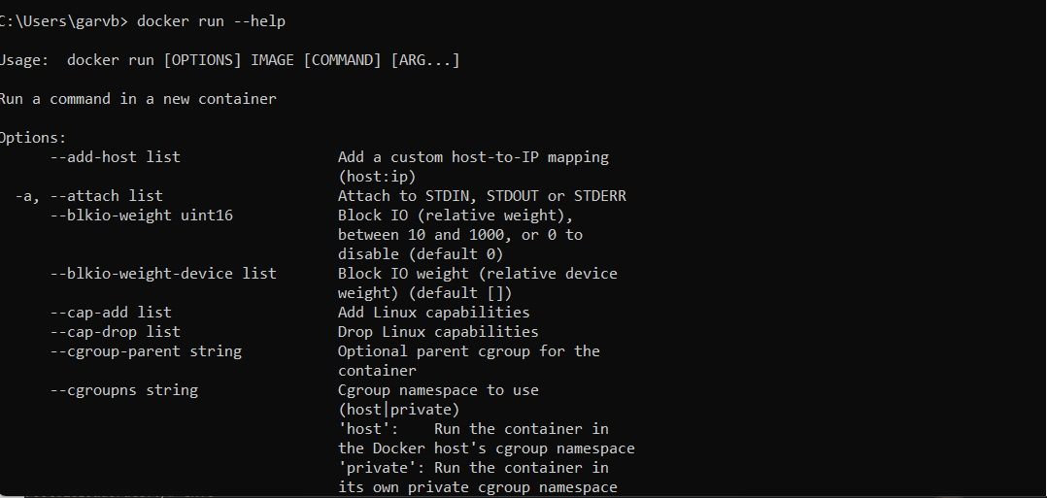

1. Docker run –tty

1. Docker run –interactive

1. Docker run –label list

1. Docker run –init

